]
Protocol for Specimen Collection, Field Testing, Specimen Processing, Storage, and Shipment to CHSU

Malawi National Micronutrient component of DHS

Malawi 2015/2016

Contents

Introduction…………………………………………………………………………………………….3
Overall Universal Precautions and Considerations 3
Overview: Cold Chain Logistics in the field laboratory 3
Essentials of Cold Chain Logistics 4
Overview: Responsibilities of Laboratory Personnel 6
Overview: Labelling Procedures 8
Labeling of Biological Specimens 8
Extra Labels 11
Blank Labels 11
Labelling of Cryovial Boxes 12
Procedure for Specimen Collection in the community field lab 13
Duties Prior to Specimen Collection 13
Venous Blood Collection 13
Specimen Field Testing 16
Malaria Testing 16
Hemoglobin Measurement with HemoCue 301 and AnemoCheck 16
Urine Field testing 17
Procedures for Specimen Processing in the Field 18
Duties Prior to Specimen Processing 18
Prioritizing Specimen Processing in the Field 20
Processing Blue Top Vacutainers in the Field 21
Processing Purple Top Vacutainers in the Field 22
Prepare whole blood lysate for RBC folate (women only)………… ………………………..23
Prepare DBS samples (for PCS only)…………………………….…………… ………………24
Sorting of Cryovial Boxes 26
Transportation of Specimens from the Field to the Laboratory 26
Lab Procedures for Specimen Storage 26
Storing Specimens in the district laboratory 26
Storing Specimens at CHSU 27
Specimen Shipment 27
Annexes 30

Introduction

This manual is for the laboratory component of the Malawi National Micronutrient Survey (MNMS) that is being integrated with the Malawi Demographic Health Survey (DHS) in 2015-16.

This training manual is to serve as a detailed guide for the MN survey laboratory personnel, supervisors and regional coordinators. The manual provides detailed methodology for field procedures, including universal precautions, management of the cold chain, labeling, specimen collection and processing, storage and shipping.

This guide should be read carefully prior to the field work, and any questions should be discussed with the survey coordinator (Eunice Nyrendra), principal investigators (Isaac Chirwa, NSO, and Ben Chilima, CHSU), laboratory Coordinator (Jellita Gondwe), and CDC technical support team (Parmi Suchdev, Carine Mapanago, Katie Tripp, Stella Fagbemi, Elizabeth Rhode and Anne Williams).

You should study this manual and learn its contents since this will reduce the amount of time needed for training and will improve your chances of being selected as a team member.

For details on the background and objectives of the MNMS, please see the Training and Field Manual.

Overall Universal Precautions and Considerations

- Collection, testing, and processing of biological specimens are critical parts of the Malawi National Micronutrient Survey

- Specimen collection, processing, transport, and storage must be done with great care so that the laboratory results are valid and accurately reflect the micronutrient status of the survey subjects.

- Universal precautions are procedures that must be followed by all team members to prevent exposure to HIV, hepatitis, and other infectious agents that are encountered during all collection, processing and handling of biological specimens.

- ALL specimens should be considered as POTENTIALLY INFECTIOUS. Practice of universal precautions (Annex 1) is essential throughout specimen collection, transport, processing, storage, and shipment.

- In case of any potential exposure to bloodborne pathogens, stop all work and immediately notify your team supervisor

Overview: Cold Chain Logistics in the field laboratory

In each of the 105 MNMS clusters, a community field laboratory will be set up in a tent in a chosen central location. The community laboratory provides a clean, cool and dry space to process specimens. It will include items such as portable freezers, portable centrifuges and hood, HemoCue 301, AnemoCheck, generators as well as all the necessary supplies and equipment for daily field work.

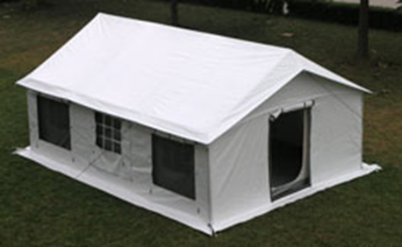

It is essential that proper cold chain logistics (Annex 2) are followed throughout the survey. Cold chain follows biological specimens from initial collection until specimen analyses. All team members should be aware of cold chain logistics and assist the nurses and lab technicians in maintaining the cold chain during field work.

Portable Freezers and Cold Boxes

- Portable freezers and cold boxes (Figure 1) will be used in the field to ensure the proper storage of the specimens in the field.
- Each team will have two portable freezers: one portable freezer will contain frozen gel packs and the second will contain processed specimens for temporary storage until transport to the central laboratory in Lilongwe.

Figure 1. Portable Freezer and Cold Box

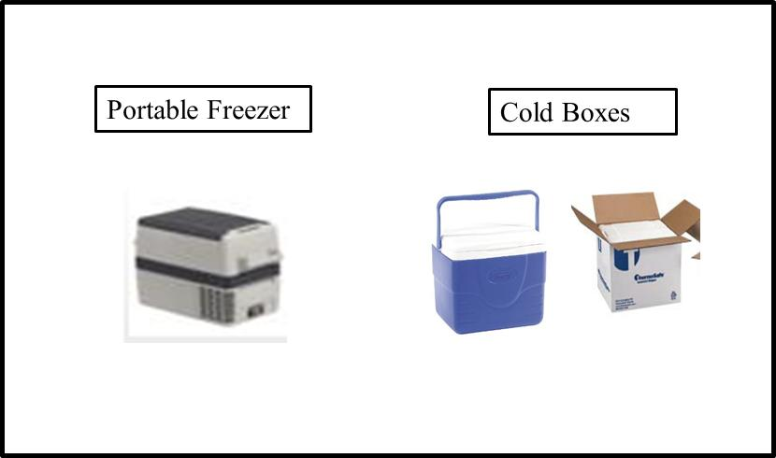

- A cold box with a handle will be provided to the nurses and for ease of storage and transport of specimens in the field.
- Additional Styrofoam cold boxes can also be made available to the nurses if extra cold boxes are needed.

- Portable freezers are used in the field to keep gel packs frozen and to store specimens after they have been processed.

- Frozen gel packs will be used in the field to keep specimens cool after specimen collection in the community field lab and frozen after processing in the field.
  - Note that it can take up to 48 hours to initially freeze gel packs until hard. Be sure to place enough gel packs into a ≤-20°C freezer prior to the start of the survey.
  - Extra frozen gel packs will be available in a -20°C located at a pre-selected nearby district laboratory so that enough frozen gel packs are available each day.
    - Be sure to refreeze gel packs which are used during the day so that there will be a constant supply of frozen gel packs available each day.

- Cold boxes can be used in the field to store specimens after specimen collection in the community field lab and prior to specimen processing:
- Each cold box should contain a minimum of (4-5) frozen gel packs, (1) digital thermometer, (1) vacutainer rack for collected specimens, and a small strip of popping plastic (bubble wrap), which should be placed between the frozen gel packs and the vacutainer rack to prevent freezing of the collected specimens.

Essentials of Cold Chain Logistics

- BLOOD SPECIMENS SHOULD NEVER BE FROZEN OR PLACED INTO THE PORTABLE FREEZERS UNTIL THEY ARE PROCESSED.
  - Prior to being centrifuged and transferred to cryovials, blood specimens in the Vacutainer should ONLY be stored in a cold box containing a few frozen gel packs. Do not allow specimens to touch frozen gel packs directly because they might freeze.

- Only open lid to cold box when placing new specimens into the cold box or when replacing thawing gel packs.
  - When you open the cold box, record the temperature of the inside of the cold box on the “Transmittal sheets B/Biological Specimen Control Form” (Annexes 3a).
  - The temperature inside the cold box should always remain <8°C.
  - The Nurse and Laboratory Technician should replace thawing gel packs with frozen gel packs when temperature is ~6°C.
    - The Laboratory Technician will have the frozen gel packs close to them in one of the portable freezers. The Nurses and/or laboratory technicians can exchange thawing gel packs with frozen gel packs at the same time as the delivery of specimens to the Laboratory Technician for processing.
- At the end of each day, the Laboratory Technician should ensure that all gel packs are placed into the ≤-20ºC freezer in the pre-selected district level laboratory every evening so that they are frozen until hard and available for use in the cold boxes during the next day’s field use.
  - Additional frozen gel packs will be available at the district laboratory facility.
  - Processed specimens should be placed into a ≤20°C freezer for storage until transported to CHSU.
  - A designated Laboratory Technician of the district laboratory will ensure the temperature of the freezer is monitored each day and record the temperature on their temperature logs temperature of the freezer each day using the “Freezer Temperature Monitoring Form” (Annex 7a).

- The Laboratory regional coordinators should designate a Laboratory Technician or Nurse in each district to monitor the temperature of the refrigerator/cold box each day using the “Refrigerator Temperature Monitoring Form” (Annex 7b).

- To ensure the proper transport of biological specimens, procedures for cold chain logistics need to be maintained to avoid adverse effects on specimen results (see Table 1 below).

Table 1: Cold Chain Logistics
 | Community Field Laboratory (Specimen collection) | Field (Processing) | Vehicle | Laboratory (Storage) | Transport (Courier/Vehicle) | Laboratory (Analysis)
Procedure | Blood collection  Urine collection  DBS samples | Centrifuge Blue Top and Purple Top Vacutainer | Transport to Laboratory (processed specimens) and urine specimens | Storage of specimens (freezer), and MRDR doses (refrigerator or cold box with frozen gel packs) | Transport to CHSU | CHSU: UI  Juergen’s Laboratory:  Serum Fer, sTfR, CRP, AGP and RBP  CHORI: serum zinc  CDC Atlanta: RBC & serum folate, B12  Cincinnati: DBS sample
Packaging | Cold Box | Portable Freezer and centrifuge | Cold Box and Portable Freezer | Refrigerator/  Freezer | Packed on frozen gel packs for transport/ shipment to designated laboratory on dry ice | Freezers
Temperature | < 8ºC (Replace thawing gel packs at ~6°C) | -20ºC | < 8ºC (Replace thawing gel packs at ~6°C) for cold box and -10º -20ºC for Portable Freezer | 1-6°C (refrigerator)  -20ºC /-70ºC  (freezer) | <-10ºC | ≥-70ºC
Cold Chain | Store blood specimens in cold boxes that are maintained with frozen gel packs (replace thawing gel packs with frozen gel packs as needed)  Transfer urine into labelled cryovials and place into cold box | Transfer serum and/or plasma into labelled cryovials and place in cyrovial boxes inside the Portable Freezer  Transfer urine specimens into Portable Freezer | Add new frozen gel packs before transport | 1-6°C (refrigerator)  -20ºC /-70ºC  (freezer) | Cold Box | ≥-70ºC freezer
Verification method | Digital Thermometer | Digital Thermometer | Digital Thermometer | Thermometer | Thermometer | Thermometer

Overview: Responsibilities of Laboratory Personnel

- There are several laboratory personnel involved in the survey including, Nurses, Laboratory Technicians, Field and Hygiene specialist, Laboratory regional coordinators and CHSU Laboratory Coordinator:

- The Enumerator/Food and Hygiene staff is responsible for:
  - Conducting the HH interview.
  - Assigning a lab ID and label the questionnaire columns for those eligible in the HH.
  - Collecting food samples from households.
  - Transferring household members to the community field lab

- The Nurse (2 per team) is responsible for:
  - Assisting in setting up the tent and field lab daily in each cluster.
  - Cleaning working area prior to specimen collection
  - Performing venepuncture on selected participants
  - Specimen collection and testing in the community field laboratory (Annex 5: Flow Chart for Specimen Field Testing and Field Processing)
  - Conducting field testing (including Hb testing with HemoCue & AnemoCheck, Malaria, urine dipstick)
  - Maintenance of the cold chain in the field (Annex 2)
  - Organization of supplies needed for specimen collection in the field every day (Annex 4a).
    - Each day enough supplies need to be available for a total of 10-11 households per day (plus 10% extra supplies).
- Recording participant label and specimen information on the “Transmittal sheet B” (Annex 3a).
  - Understand all aspects of data collection and conduct field testing
  - Ensure Hemocues, AnemoCheck, freezers, centrifuge and other equipment are calibrated and functioning properly
  - Keep in daily contact with the regional coordinator and team supervisor during the field work.
  - Assist in performing anthropometry
  - Make sure the necessary supplies and equipment are ready the night before each day of field work.
  - Manage the work flow in the community field lab and maintain all documentation regarding the completion of the cluster
  - Ensure labels are appropriately used and forms completed correctly
  - Review all data collection forms for consistency and completeness.
  - Serve as back-up and assist team members if they need help.
  - Ensure any difficulties with equipment/supplies are communicated to the team supervisor/coordinator as soon as possible
  - Troubleshoot any problems with fieldwork, request support if needed.
  - Remaining flexible for accepting any reasonable tasks assigned that are not listed above
  - A flowchart of responsibilities for the Nurse is located in Annex 15

- The Laboratory Technician (2 per team) is responsible for:
  - Processing all the specimens in the field (Annex 5)
  - Organization of supplies needed for specimen collection in the field every day (Annex 4b).
    - Each day enough supplies need to be available for a total of 10-11 households per day (plus 10% extra supplies).
  - Setting up the tent, field hood and clean working area to process specimens.
  - Recording participant label and specimen information on the “Transmittal sheet C” (Annex 3b).
  - Maintenance of the cold chain in the field at all times (Annex 2).
  - Responsible for storage of specimens while in the field and assisting the Laboratory Coordinator in transporting specimens to the laboratory.
  - Secondary phlebotomist to assist nurse with venous blood collection
  - Performing anthropometry
  - Help conduct testing for hemoglobin, malaria, urine dips stick in the field lab
  - Ensure Hemocues, AnemoCheck, freezers, centrifuge and other equipment are calibrated and functioning properly
  - Ensure that bio hazardous materials are disposed of properly and safely.
  - Ensure proper sample labelling
  - Process samples as soon as possible after blood collection (centrifugation, separation, storage)
  - Assist in setting up the field lab in each cluster
  - A flowchart of responsibilities for the Laboratory Technician is located in Annex 16

- The team supervisor (1 per team) is responsible for:
  - Ensuring storage of specimens in the regional Laboratory at -70°C.
  - Assisting the Laboratory Coordinator with delivering or shipping the specimens to CHSU.
  - Understand all aspects of data collection and supervise its timely and correct implementation following all appropriate procedures specified in the field manual.
  - Communicating with DHS teams on a daily basis
  - Keeping in daily contact with the regional coordinator and survey coordinator during the field work.
  - Requesting support from a community-based health worker for the cluster, if possible.
  - Transferring relevant information form the questionnaire and cover sheets to the Transmission forms (Forms A, B and C)
  - Making sure the necessary supplies and equipment are ready the night before each day of field work.
  - Managing the work flow in the cluster and maintain all documentation regarding the completion of the cluster
  - Organizing transportation or provide directions for HHs members to the field lab
  - Ensuring collection of food samples from households
  - Ensuring cold chain is maintained in the field
  - Overseeing the work performance of the team members
  - Ensuring labels are appropriately used and forms completed correctly
  - Reviewing all data collection forms for consistency and completeness.
  - Reviewing all data collection forms daily for consistency and completeness. Performing edits to the paper version micronutrient questionnaire in red ink. If missing values are identified, try to resolve them the following day while the team is in the cluster.
  - Serving as a back-up for the team; assist team members if they need help.
  - Ensuring any difficulties with equipment/supplies are communicated to the survey coordinator asap
  - Troubleshooting any problems with fieldwork.
  - Remaining flexible for accepting any reasonable tasks assigned that are not listed above

- The CHSU Laboratory Coordinator and CDC Laboratory Representative are responsible for:
  - Laboratory and field work planning/supervision
  - Survey Training
  - Quality control oversight.
  - Ensure cryovial boxes are properly labelled by Laboratory Technicians and sorted according to specimen type and age group
  - Routine transfer of specimens to Lilongwe.
  - Transport of specimens in the field to the regional laboratories.
  - Transport of specimens and maintenance of cold chain between the district/regional labs and CHSU.
  - Ensuring specimens are properly stored in the designated labs for analysis.
  - Overall support and supervision of all laboratory procedures.

Overview: Labelling Procedures
Always read labels carefully before affixing them to anything. Match the survey participant to the label and to the correct specimen or box to be labeled.

Labelling for Household Questionnaires and Food Specimens

The food and hygiene technician will be responsible for labelling all wrist ID bracelets, food specimens, as well as the child, woman and man questionnaires. However, it is important to note that all team members should be familiar with the different labels:
- HH Questionnaire (1)
- Transmittal form A (1)
- Food Samples (6)- one for Ziploc bag and one questionnaire for each food item
- Extra label (1)

Labelling of Biological Specimens

The nurse and lab technician will be responsible for labelling the biological specimens in the community field lab. Each age group will be assigned their own set of labels because different specimens will be collected for each. The different age groups include:

- Pre-school children (PSC) 6-59 months
- School aged children (SAC) 5-14 years
- Women of reproductive age (WRA) 15-49 years
- Adult men 15-49 years

Each Child 6-59 months will have a set of 15 large labels (Figure 3):
- Questionnaire (1)
- ID Bracelet (1)
- Transmittal Form B & C (2)
- Blue Top Vac (1)
- Purple Top Vac (1)
- MRDR Purple Top (1)
- DBS sample (2)
- Urine Cup (1)
- Serum Vial from Blue top (2) -1 for analysis and 1 for backup
- Plasma Vial (1) - 1 for backup
- Extra Labels (3)

Each school age child 5-14 years will have a set of 15 large labels (Figure 3).
- Questionnaire (1)
- ID Bracelet (1)
- Transmittal Form B & C (2)
- Blue Top Vac (1)
- Purple Top Vac (1)
- MRDR Purple Top (1)
- Urine Cup (1)
- Urine vial (2)- 1 for analysis and 1 for backup
- Serum Vial from Blue top (2) -1 for analysis and 1 for backup
- Plasma Vial (1) - 1 for backup
- Extra Labels (2)

Each Woman of reproductive age (14-59 years) will have a set of 18 large labels (Figure 3).
- Questionnaire (1)
- ID Bracelet (1)
- Transmittal Form B & C (2)
- Blue Top Vac (1)
- Purple Top Vac (1)
- MRDR Purple Top (1)
- Urine Cup (1)
- Urine vial (2)- 1 for analysis and 1 for backup
- Serum Vial from Blue top (3) -2 for analysis and 1 for backup
- Plasma Vial (1) - 1 for backup
- RBC Folate vial (2)- 1 for analysis and 1 for backup
- Extra Labels (2)

Each Man 20-55 years will have a set of 12 large labels (Figure 3).
- Questionnaire (1)
- ID Bracelet (1)
- Transmittal Form B & C (2)
- Blue Top Vac (1)
- Purple Top Vac (1)
- Urine Cup (1)
- Serum Vial from Blue top (2) -1 for analysis and 1 for backup
- Plasma Vial (1) - 1 for backup
- Extra Labels (2)

- The Enumerator is responsible for:
  - Putting the “Questionnaire” label on the participant’s questionnaire at the start of the interview.
  - Putting the “ID bracelet” label on the participant’s ID bracelet

- The Nurse is responsible for:
  - Placing the “Transmittal Form B” labels onto the corresponding form.
  - Placing the “Blue Top Vac”, ““BD Purple Top”, “MRDR Purple Top”, “Urine Cup”, “Urine Vial” labels on the corresponding vacutainers, cups, and vials right after specimen collection

- The Laboratory Technician is responsible for:
  - Placing the “Serum Vial 1-3”, “Plasma Vial”,“ MRDR vial 1-2”, and “RBC Fol vial 1-2” labels on the cryovials after processing
  - Placing the “Transmittal Form C” label on the corresponding form.

Figure 3: Example of labels used in the community field laboratory- Labels for PSC

PCR Vial Labels

- In addition to these larger labels there is also a small white label for the 0.2mL PCR vial (to be shipped to Germany).

- The small white PCR labels come on a large sheet of many labels (Figure 4).

- The correct corresponding label should be used to label the PCR tube so that the number on the larger labels matches the number on the small label for each participant.

- Blank PCR tube labels will also be provided if a label is missing or damaged.

Figure 4: Small white label for 0.2mL PCR tubes

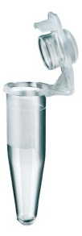
5001

- Labelled 0.2mL PCR tubes will be stored in a Ziploc bag and then placed into a cryovial box for easy storage.
  - The 0.2mL PCR tubes can be consolidated at the end of each day into one Ziploc bag, which is housed in a cryovial box.
  - BE SURE NOT TO OVERFILL THE ZIPLOC BAG. IT SHOULD FIT EASILY INSIDE THE CRYOVIAL BOX.
  - The cryovial boxes containing the labelled 0.2mL PCR tubes will then be shipped to Germany for analysis.

Extra Labels

- Each set of labels will have some additional “Extra” labels. These can be used in cases where labels may have been torn or damaged.

- Write the sample description on the label using a marker pen.

- While in the field, Laboratory Technicians sort labelled cryovials into individual boxes and label the specimen type and age group (e.g., “Serum Vial 1- children 6-59 months”) on the outside of the box. More details on this topic will be mentioned under “Procedures for Processing Specimens in the Field.”

- Cryovial boxes will have to be appropriately labeled (Figure 5).

Figure 5: Labelling of Cryovial Boxes

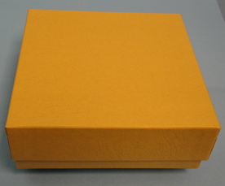

- Each box will be labelled with 3 box labels:
  - One label goes on the top of the box lid, another goes on the side of the box lid, and the last goes on the side of the bottom of the box (Figure 3).
  - The team supervisors and laboratory coordinators are responsible for ensuring cryovial boxes are properly labelled and specimens properly sorted into cryovial boxes by the Laboratory Technicians.
- Cryovial boxes will then be numbered numerically so that the specimen inside the box can be assigned to a specific cryovial box for the specimen inventory.
- The regional laboratory coordinators and lab coordinator will work together to assign box numbers. The box numbers should not be duplicated (e.g., one box will receive “Specimen type_cluster#_Box#1”, the second box will receive Specimen type_cluster#_Box#2, etc.). The box number must then be recorded on the “Transmittal Form C” (Annex 3b).

- At CHSU, the Laboratory Coordinator and technicians will work together to receive and inventory box numbers:
  - A specimen inventory will also need to be generated by the Laboratory Coordinator at CHSU. The specimen inventory will include each specimen ID within a specific box.
  - The specimen inventory will be sent along with the specimens to the designated laboratory

- All specimens will be in a -70°C freezer at the CHSU Laboratory in Lilongwe until analysis or stored (long-term) as backup specimens.
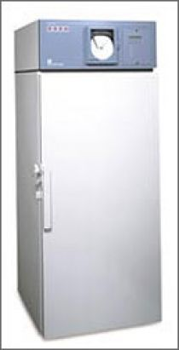

REMEMBER: Read the labels carefully before affixing them to anything.
Match the survey participant to the label and to the correct specimen to be labeled.

Procedures for Specimen Collection in the field laboratory

Duties Prior to Specimen Collection:

- The Nurse should pack the backpack with all the supplies needed for daily field use (Annex 4a).
- Check all field equipment (HemoCue 301, AnemoCheck, freezers, centrifuges, etc..)

Specimen Types:

- The Nurse will be responsible for collecting several types of specimens, including blood and urine
- The type of specimens collected will be as follows:
  - Children 6-59 months Blood, urine and DBS samples
  - Children 5-14 years Blood and urine
  - Women of reproductive age 15-49 years Blood and Urine
  - Adult men 20-55 years Blood and urine

Venous Blood Collection:

- Obtain informed consent for blood collection
- Set up all the supplies needed for the blood collection. This requires a comfortable location with a flat surface sufficiently large to lay out the absorbent pad and all equipment and supplies prior to collecting the venous sample from the participant.
- For small children, have the mother or caretaker hold the child.
- Collect the venous blood specimen (Annex 6: Procedure for Venous Blood Collection). Sterile butterfly needles and vacutainers will be used for venous blood collection (Figure 5):

Figure 5: Types of Vacutainers

The amount of blood collected and number of vacutainers will depend on the age group:
- For all participants, fill one Blue Top Vacutainer with ~5 mL blood
- Fill one Purple Top Vacutainer:
- You will need a minimum of ~2 mL of blood for PSC and SAC
- You will need a minimum of ~3 mL blood for WRA and Men
- For the MRDR sub-study, fill a second Purple Top Vacutainer with ~3 mL blood

 | Blue Top-Vol (mL) | Purple Top-Vol (mL) | MRDR Purple Top-Vol (mL)
PSC | 5 | 2 | 3
SAC | 5 | 2 | 3
WRA | 5 | 3 | 3
Men | 5 | 3 | n/a

- Children 6-59 months 1 Blue Top Vacutainer, and 1 Purple Top Vacutainer
- Children 5-14 years 1 Blue Top Vacutainer, and 1 Purple Top Vacutainer
- Women 15-49 years 1 Blue Top Vacutainer, and 1 Purple Top Vacutainer
- Men 20-55 years1 Blue Top Vacutainer, and 1 Purple Top Vacutainer

- Mix the specimens gently.
- The Nurses will have only two opportunities to collect blood each participant.

- The vacutainers should then be labelled with the correct corresponding participant’s label. The Nurse should also place the participant’s label on the “Biological Specimen Control Form/Transmittal Form B” for Nurses (Annex 3a).

- All waste obtained in the community field lab should be appropriately disposed of using sharps containers (i.e., needles) and autoclave bags (i.e., gauze, alcohol swabs, kimwipes, gloves, etc.) (Annex 1: Universal Precautions).

- All vacutainers should be stored in a vacutainer rack inside the cold box. Be sure that the vacutainers are separated from the frozen gel packs using bubble wrap.
- Do not let the Vacutainers come in direct contact with the frozen gel packs because they might freeze and will be ruined!
- Record the temperature of the cold box on the “Transmittal sheet/Biological Specimen Control Form” when placing specimens inside the cold box (Annex 3a).

Urine Collection:
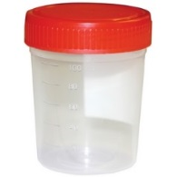
- The Nurse will collect urine cups from all age groups but the lab technician will only prepare (2) urine aliquots for the following age groups:
- Children 5-14 years
- Women 15-49 years

- The Nurse should provide each participant with a labelled urine cup and provide specific instructions (Annex 10: Directions for Urine Collection) regarding the urine collection process.

- If a participant is unable to provide a urine sample before the team leaves the field laboratory, then the Nurse should recommend that the participant drink some water so that the participant might be able to provide a sample.

- Each participant will be asked to provide a minimum of 5mL of urine into the collection cup

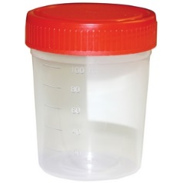
- Once collected, all urine cups should be stored inside the cold box until testing and processing

Specimen Field Testing
- Field testing (blood specimens)

The Nurse is responsible for malaria testing and hemoglobin measurements and specimen collection in the field.

The Purple Top Vacutainer labelled “Purple Top Vac” will be used for malaria testing and hemoglobin measurement (using both the HemoCue photometer and AnemoCheck) from whole blood

Malaria Testing:

- Malaria should be checked using a rapid malaria antigen (HRP2) SD Bioline test kit for Plasmodium falciparum (Annex 8; Procedure for Checking Malaria Using the Rapid Malaria Test Kit).
  - Results take 15 minutes, so it is important to start the malaria test prior to measuring the hemoglobin.
  - Use a timer so that the 15 minutes can be monitored and the results are taken in the correct amount of time.

- Once the test is complete, record the result on the questionnaire and inform the participant of the result.

- For ALL participants who test positive for P. falciparum, the Nurse should complete a “Referral Slip” (Annex 9) and refer the participant to the nearest local health center.

Hemoglobin Measurement with HemoCue and AnemoCheck:

- While waiting on the results from the malaria tests, the Nurse should proceed to measuring the hemoglobin using the:
        - HemoCue® Hb-301 photometer (Annex 11)
        - then the AnemoCheck (Annex 14)

- Once hemoglobin has been measured, the Nurse should record the result on the questionnaire (be careful to enter the correct value to the corresponding instrument on the questionnaire)

- Inform the participant of the result (using the Hb value obtained from the HemoCue 301).

- The hemoglobin cut-offs will vary depending on age:

  - Children 6-59 months severe anemia: <7.0 g/dL
  - Children 5-14 years severe anemia: <5.0 g/dL
  - Non-pregnant Women 15-49 years severe anemia: <5.0 g/dL
  - Pregnant Women 15-49 years severe anemia: <7.0 g/dL
  - Men 20-55 years severe anemia:<5.0 g/dL

- If the participant has a hemoglobin level (from the HemoCue 301) less than the severe anemia cut-off, then the participant should be provided with a “Referral Slip” (Annex 9) to refer the participant to the nearest local health center.

See Referral criteria in table below:

 | Preschool children | School children | Women | Pregnant women | Men | Comments
Severe anemia | Hb < 7.0 g/dL | Hb < 5.0 | Hb < 5.0 | Hb < 7.0 | Hb < 5.0 | Refer to clinics
Malaria | +RDK | +RDK | +RDK | +RDK | +RDK | Refer to clinics
Severe acute malnutrition | MUAC < 11.5cm or bilateral edema | MUAC < 14.0 cm or bilateral edema | MUAC < 16.0cm | MUAC < 16.0cm | MUAC < 16.0cm | Refer to clinics
Urinary Schisto | Hematuria | Hematuria | - | Hematuria | Hematuria | Refer to clinics
Other illness | Diarrhea with dehydration, fever, pneumonia, etc. |  |  |  |  | At discretion of nurse, refer to clinic

- Field Testing (urine)

The Laboratory Technician will divide the urine into two cryovials for the following target groups only: school-aged children and women of reproductive age. The urine vials will be used to measure urinary iodine:

- Gently mix the urine before aliquoting (be sure the cap of the urine cup is securely tightened).
- Using a disposable transfer pipette, transfer 1mL urine into each cryovial and cap.
- Place the cryovials into 2 labelled cryovial boxes (one for “Urine Vial 1” and one for “Urine Vial 2”).
- Find the appropriate participant’s number on the “Transmittal form C/Biological Specimen Control Form” and mark collected for urine.
- Place all cryovials into a separate cryovial box and separate according to vial type (e.g., Urine Vial 1_SAC_cluster#_box1, Urine Vial 2_SAC_cluster#box1, etc.) and store in the portable freezer
- The Laboratory Technician will also perform the urine dipstick test on all participants:

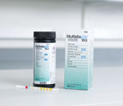
- Immerse reagent strips (which comprises different chemical pads) into urine cup.
- Use one reagent strip per participant
- Reagent strip includes a reagent pad which reacts (i.e. changes color) in the presence of blood
- Remove reagent strip from urine sample after one minute (the test is ready to be read in 60 seconds)
- Visually compare reagent strip against manufacturer’s colored scale

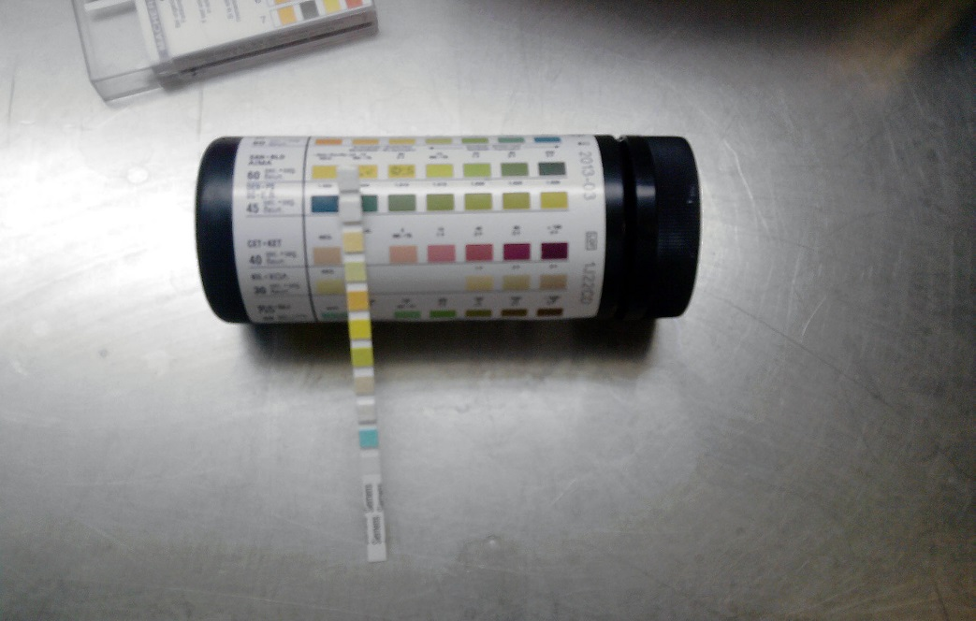

- Record result on questionnaire (see example below):

Procedures for Specimen Processing in the Field

Blood specimens will be processed by the Laboratory Technician. Urine specimens will be processed by the Nurse and transferred to the Laboratory Technician for storage in the portable freezer.

Processing Blood Specimens- Laboratory Technician
Duties Prior to Specimen Processing:

- The Laboratory Technician should pack the backpack with all the supplies needed for daily specimen processing in the field (Annex 4b).

- Set up the tent, field hood and clean working area to process specimens.
  - Set up all the equipment and supplies needed for specimen processing and storing. This requires a comfortable location with a flat surface sufficiently large to lay out the absorbent pad and all equipment and supplies prior to processing and storing the specimens in the field.

- The Laboratory Technician is responsible for retrieving all specimens from the Nurse and processing the blood specimens in the field. Be sure to obtain the Laboratory Technician’s initials on the “Transmittal Form B Form” (Annex 3a) when the specimens are transferred. You will also be required to initial and record the time of transfer on the Laboratory Technician’s version of this form (Annex 3b).

- The Laboratory Technician must initial the Nurse’s version of the “Transmittal Form B/Biological Specimen Chain of Custody Form” (Annex 3a) when the specimens are transferred.

- Be sure to also have the Nurse initial and record the time of transfer on the Laboratory Technician’s version of this form, i.e. Transmittal Form C (Annex 3b) when receiving specimens.

- The serum from the Royal Blue Top Vacutainer will be used to measure serum zinc, serum folate,serum ferritin, sTfR, CRP, AGP and RBP( ELISA)
- Whole blood lysates and DBS samples will be prepared from the Purple Top Vacutainer after field testing.
- The plasma from the Purple Top Vacutainer will be used as a backup specimen
- Processed specimens will be placed into cryovials tubes (Figure 6).

Temporary hoods
In order to avoid external Zinc contamination, processing of the samples will be carried out under a temporary field hood:

- Position the provided plastic storage box on its side
- Remove the lid
- Each day, wrap fresh cellophane foil around the top half of the opening (in order to reduce the size of the opening while allowing the lab technician to aliquot samples)
- At the end of each day (or when dirty), make sure to clean the box with alcohol
- Store the box with the lid closed to keep clean until next day

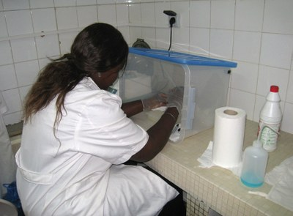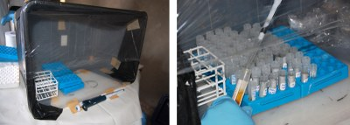

- Portable centrifuges for processing of samples in the field:
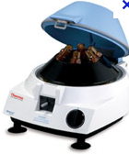

- Centrifuge whole blood sample in Vacutainers at 3,500 rpm for 10 minutes to separate serum or plasma (Note: Serum is the blood product produced after centrifugation of the Blue Top Vacutainer and does not contain blood clotting factors and cells. Plasma is the blood product produced after centrifugation of the Purple Top vacutainer and contains blood clotting factors (fibrinogen))
- Using a sterile transfer pipette, pipette the serum or plasma into a sterile vial
- Screw cap on firmly to prevent leakage
- Attach the correct label

Figure 6. Cryovials Tubes Used to Store Processing Specimens

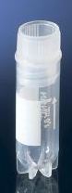

Cryovial

Prioritizing Specimen Processing in the Field:

- The Blue Top Vacutainers MUST be centrifuged within 1 hour of specimen collection. These are ALWAYS the FIRST PRIOROTY for processing.
- The SECOND PRIORTY is to prepare the whole blood lysate (2 vials) for RBC folate analysis using the Purple Top Vacutainer labelled “Purple Top Vac” within 4 hours of specimen collection.
- The remaining procedures (i.e. preparation of DBS samples) can be carried out in the field if there is sufficient time. If not then at the end of the day in the laboratory.

- Prioritizing Specimen Processing in the Field Lab:
- The Blue Top Vacutainers must be centrifuged within 1- 2 hours of specimen collection. These vacutainers are always the first priority for processing.
- The second priority is to process the Purple Top Vacutainer after:
- preparing the whole blood lysate (2 vials) for RBC folate analysis using the Purple Top Vacutainer for women
- preparing the DBS samples for PSC
- The remaining procedures (i.e. centrifugation of the Purple Top Vacutainers for MRDR) can be carried out in the field if there is sufficient time. If not then at the end of the day in the laboratory.

- Processing Blue Top Vacutainers in the Field:
  - Centrifuge the Blue Top Vacutainers at 3,500 rpm for 10 minutes.
  - Using a fixed pipette, transfer 100 µL of serum to a PCR tube and affix the “PCR Vial 1” label with the correct participant’s number (i.e. the number that matches the number from the Blue Top Vacutainer)
  - Using a sterile disposable transfer pipette, transfer serum to a cryovial and affix the “Serum Vial 1” label with the correct participant’s number (i.e. the number that matches the number from the Blue Top Vacutainer).
  - For women only, transfer serum into a second cryovial and affix the “Serum Vial 2” label with the correct participant’s number.
  - Transfer the remaining serum into a third cryovial and affix the “Serum Vial 3” label with the correct participant’s number
  - These 3 cryovials will go into 3 different cryovial boxes, one for Serum Vial 1, one for Serum Vial 2 and one for serum vial 3.
  - Store the processed specimens in the portable freezer until they are transferred to the laboratory at the end of each day.
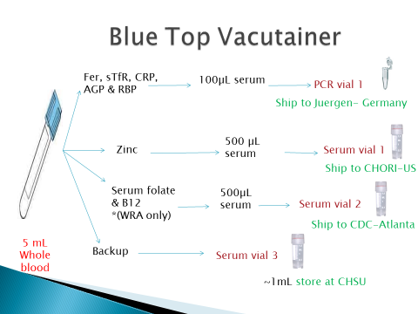

Processing Purple Top Vacutainers in the Field:

SECOND PRIORITY FOR PROCESSING IN THE FIELD

- After processing the Blue Top Vacutainer, the following procedures are performed to the Purple Top Vacutainer.
- Prepare whole blood lysate (2 vials) for RBC folate analysis in women only
- Prepare DBS samples for PSC only
- Centrifuge all Purple Top Vacutainers to collect remaining plasma into a cryovial for backup (1 vial).
- Centrifuge the MRDR Purple Top Vacutainers to collect the plasma for MRDR/retinol (2 vials) in PSC, SAC and WRA.
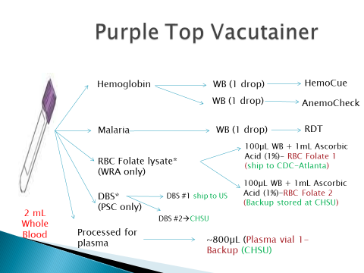

- Prepare whole blood lysate (2 vials) for RBC folate analysis (FOR WOMEN ONLY):
Prior to centrifugation of the Purple Top Vacutainer, prepare the whole blood lysate:
- Prepare a 1% solution of ascorbic acid in water in a 50mL tube.
  - This solution will need to be prepared fresh daily.
  - Obtain a new vial of ascorbic acid (0.5g).
    - The pre-weighted vials of ascorbic acid will be prepared by CDC prior to the survey.
  - Remove the cap of the 50mL tube and add bottled water to the 50mL mark.
  - Before opening the lid to the vial containing the ascorbic acid, tap the top of the vial to be sure all powder is at the bottom of the vial.
  - Remove the cap of the 50mL tube and add bottled water to the 50mL tube up to the 50mL mark.
  - Gently open the vial containing the ascorbic acid and pour the powder into the 50mL tube containing the water.
    - Be sure to tap the vial so that all powder is removed.
  - Replace the cap of the 50mL tube and mix until all ascorbic acid is dissolved.
  - Be sure to store the 50mL tube in a cold box with frozen gel packs while not in use.
    - Try to avoid direct contact with sunlight when using the 1% solution of ascorbic acid.
- Pipette 1mL of this 1% solution of ascorbic acid into 2 cryovials.
- Mix the Purple Top Vacutainer well, and then pipette 100µL whole blood into each of the 2 cryovials.
- Cap the cryovials and mix well. Label each with its corresponding “RBC Folate Vial 1” and “RBC Folate Vial 2” labels.
- Place all cryovials into a separate cryovial box (1 for RBC Folate Vial 1 and 1 for RBC Folate Vial 2) and store in the portable freezer.
- Prepare DBS samples for PSC only:
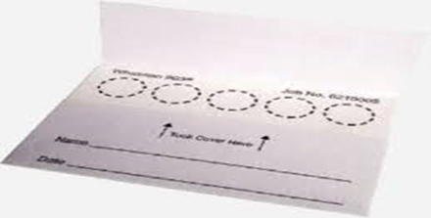
- Collect venous blood by venipuncture using standard practice (see Annex 6)
- Write the date as dd/mm/yyyy on filter card
- Stick the corresponding child’s “DBS barcode label” in the space labelled “Name”.
- Ensure that the barcode matches the one on the Vacutainer.
- Place the labelled filter paper horizontally on a drying rack
- Mix Purple top tube well by inverting several times, to anticoagulate the blood
- Remove vacutainer top
- Pipette 125µL blood directly on DBS card circle: position the pipette vertically approximately 1cm above the filter paper card and dispense the blood in the middle of the first printed circle.
- Spot blood on two circles per participant
- Do not touch or smear the sample on the filter paper
- Place the completed DBS card into a drying rack to dry
- Place one card per slot to prevent cards from touching each other
- Allow each card to dry for 2-3 hours. Do not artificially dry with heat or sunlight
- Blood spots should be a dark brown color once dried
- Dried cards should be placed into a large Ziplock plastic bag with desiccant

- Centrifugation of Purple Top Vacutainers to collect the plasma as backup (1 vial):
LOW PRIORITY FOR PROCESSING IN THE FIELD
- Centrifuge the specimens at 3,500 rpm for 10 minutes.
- The remaining plasma is transferred into a cryovial and labelled with corresponding “Plasma Vial 1” label.
- Place each cyrovial into a separate cryovial box (1 for Plasma Vial 1) for storage in the portable freezer.

- Centrifugation of MRDR Purple Top Vacutainers to collect the plasma for MRDR/retinol (2 vials):
LOWEST PRIORITY FOR PROCESSING IN THE FIELD

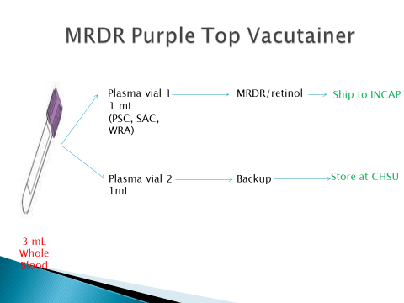

- If time permits in the field, centrifuge the MRDR Purple Top Vacutainers. If not, wait until the end of the day and process the specimens in the laboratory.
- Centrifuge the Purple Top Vacutainers at 3,500 rpm for 10 minutes.
- Using a disposable transfer pipette, pipette 1mL plasma into two cryovials.
- Cap the cryovials well.
- Label each vial with its corresponding “MRDR Vial 1” and “MRDR Vial 2” labels.
- Place each cryovial into a separate cryovial box (1 for MRDR Vial 1 and 1 for MRDR Vial 2) for storage in the portable freezer.

Sorting Cryovials into Cryovial Boxes
Cryovials must be sorted properly into cryovial boxes according to specimen type. This is essential to ensure the correct specimens are shipped to the correct laboratory for processing. Laboratory Technicians are responsible for sorting the cryovials into the correct cryovial boxes according to specimen type during the processing of specimens.
Once all specimens for 1 participant have been processed, begin to separate the specimens into separate cryovial boxes:
  - For example, all cryovials labelled “Serum Vial 1” will be placed into 1 box, all specimens labelled “Serum Vial 2” will be placed into a second box, etc.
  - Serum Vial 1, serum vial 2, 0.2mL PCR Tubes, RBC Folate Vial 1, and MRDR Vial 1 will be shipped to laboratories for analysis.
  - Serum Vial 3, Plasma Vial 1, RBC Folate Vial 2, and MRDR Vial 2 will serve as back-up specimens and will be stored long-term at -70°C in a freezer at CHSU
  - Each cryovial box will get assigned a unique number

Transportation of Specimens from the Field lab to the district Laboratory
At the end of the day (cold chain logistics):

The supervisor, with the assistance of the Nurse and Technicians, is responsible for ensuring that all the blood and urine specimens are consolidated and transferred to the laboratory for storage.

All processed specimens will be transported in the portable freezer to the nearest district level facility that has been identified as a cold chain location for temporary specimen storage:
- The team supervisor should have the district laboratories pre-selected for that particular cluster prior to daily field work
- All of the gel packs used in the field should be frozen until they are hard every night.
- The freezer must be set to at least -20º C.
- It is critical the gel packs are completely frozen until hard before teams leave for the field each day.

Lab Procedures for Specimen Storage
Storing Specimens in the district Laboratories:

- All specimens need to be stored properly in a ≥-20°C freezer within each district/region until they are transferred to CHSU Laboratory in Lilongwe
- The Laboratory Supervisor/Coordinator should ensure that all cryovial boxes have been accurately labelled with the specimen type and age group.
- All specimens will be transferred to CHSU laboratory in Lilongwe at the end of the survey for long term storage and shipment for analysis

Storing Specimens in the CHSU Laboratory (Lilongwe):

The specimens from the district level facilities will be transported back to CHSU on a bi-monthly basis

- All specimens need to be stored properly in a -70°C freezer until they are analyzed.
- Cryovial boxes will be numbered numerically so that the specimen inside the box can be assigned to a specific cryovial box for the specimen inventory.
  - Box numbers will be assigned once all specimens are received at CHSU.
- A specimen inventory should be created for all specimen boxes and divided according to specimen type.
- All backup specimens will be stored long-term in the laboratory preferably at -70°C.

Specimen Shipment/Transfer from CHSU

Supplies Needed:
- Styrofoam cold boxes
- Bubble wrap/popping plastic
- Dry ice (1 pound for every 2 hours of shipping) or frozen gel packs
- Packing tape
- Dry ice labels
- Cryovial boxes with specimens packed for shipment
- Copy of specimen inventory for the specimen type being shipped (a copy of the
inventory should also be emailed to the laboratory)

The Laboratory Coordinators are responsible for transferring and shipping specimens to the correct laboratory for analysis (see Table 2 below).

Table 2. Laboratories Identified to Analyze Survey Specimens

Laboratory Name | Contact Person & Address | Specimens Shipped
VitMin Lab (Germany) | Juergen Erhardt  Vit  Kastanienweg 5,77731 Willstaett, Germany  Tel: +49-7852-1805  Email: erhardtj@gmail.com | 0.2mL PCR serum vials
INCAP (Guatemala) | Dora Inés Mazariegos Cordero  Unidad de Nutrición y Micronutrientes (UT-UB)  Instituto de Nutrición de Centroamérica y Panamá (INCAP)  Calzada Roosevelt 6-25 zona 11, Apartado Postal 1188,  Guatemala, Centro América  Tel: (502) 2472-3762 ext 1212  Fax: (502) 2473-6529  Email: dmazariegos@incap.int | MRDR Vial
CHORI Elemental Analysis Facility  (USA) | Dr. Janet King  2005 Children's Hospital Oakland Research Institute  5700 Martin Luther King Jr Way, Oakland, California 94609  Phone 510-450-7600 • Fax 510-450-7910  Email: jking@chori.org | Serum Zinc Vial
CDC NBB  (Atlanta, USA) | Dr. Christine Pfeiffer  Nutritional Biomarkers Branch (NBB)  National Centers for Environmental Health (NCEH)  Centers for Disease Control and Prevention  4770 Buford Hwy NE,  Atlanta, GA 30341 | RBC Folate Vial  & B12 vial
CCHMC  (Cincinnati, USA) | Patrick McGann  Cincinnati Children’s Hospital Medical Care  3333 Burnet Avenue,  Cincinnati, Ohio  45229-3026 | DBS samples

- Specimens will be stored in a -70°C freezer.

- Be sure to transfer the correct specimens to the correct laboratory for analysis

  - All backup specimens (vials labelled Serum Vial 3, Plasma Vial 1, RBC Folate Vial 2, and Urine Vial 2) will remain in the laboratory and stored at -70°C.

- Assemble all materials for packing and shipping frozen specimens including Styrofoam cold box, dry ice/frozen gel packs, bubble wrap, Cryo-Temp monitor, dry ice labels and packing tape.

- Places the dry ice at the bottom of the Styrofoam cold box. If there is no dry ice, place 6-8 gel packs at the bottom of the box and follow the next steps.

- Place a layer of bubble wrap over the dry ice/gel packs so that the specimens don’t touch the dry ice/gel packs.

- Wrap the plastic storage boxes with bubble wrap and place the boxes inside the Styrofoam cold box.

- Fill empty space on top and sides of the Styrofoam cold box with dry ice/gel packs. Place a Cryo-Temp temperature monitor into each Styrofoam cold box. Close the lid of the box.

- Secure the outer lid of the box with tape. When using dry ice, the packaging must permit release of carbon dioxide gas to prevent a build-up of pressure that could rupture the package (DO NOT tape all around box).

- Record the date and time the specimens are being transported to the designated laboratory conducting the analysis on the “Biological Specimen Control Form” (Annex 3b). Make a photocopy of these forms and keep the original at CHSU. Place the form in a sealed Ziploc bag and include in the box for shipment.

- Label the shipping box with a dry ice sticker (if dry ice is used) and a “Keep frozen
Sticker”

- Label each shipping box with the address of the recipient lab. Include name, telephone number, and return address information. Contact the recipient lab before shipping the specimens to ensure that the staff is ready to receive the shipment and contact the recipient after shipment to confirm the delivery of specimens.

Annexes

Annex 1: Universal Precautions
Annex 2: Cold Chain Logistics
Annex 3a: Biological Specimen Control form for
Nurses-Transmittal Form B
Annex 3b: Biological Specimen Control form for
Laboratory Technicians-Transmittal form C
Annex 4a: List of Supplies Needed Daily by Nurses
Annex 4b: List of Supplies Needed Daily by Laboratory
Technicians
Annex 5: Flow Chart for Specimen Field Testing and Field
Processing
Annex 6: Procedure for Venous Blood Collection
Annex 7a: Freezer Temperature Monitoring Form
Annex 7b: Refrigerator Temperature Monitoring Form
Annex 8: Procedure for checking Malaria using Rapid
Malaria Antigen HRP2 Test Kit
Annex 9: Malaria Status and Referral Slip
Annex 10: Directions For Urine Collection
Annex 11: Procedure for Maintenance of HemoCue and
Measuring Hemoglobin Using the HemoCue 301-
Photometer
Annex 12: Hemoglobin status and Referal slip
Annex 13: Procedure for preparing, Drying And Storing Dried Blood Spot Samples
Annex 14: Measuring hemoglobin using the anemocheck photometer
Annex 15: Responsibilities of the Nurse
Annex 16: Responsibilities of the Laboratory Technician

Annex 1: Universal Precautions

- Universal precautions are defined by CDC as a set of precautions designed to prevent transmission of human immunodeficiency virus (HIV), Hepatitis B virus (HBV), and other blood-borne pathogens.
- Blood and other patients’ body fluids are considered potentially infectious for HIV, HBV, and other blood-borne pathogens.
- Therefore health-care workers who handle body fluids such as blood, mucus, sputum, urine, stool, etc. should observe the following precautions:
- Prevent skin and mucous-membrane exposure when handling blood or other blood-borne pathogens.
- Use personal protection barriers (e.g. gloves, lab coats and eye glasses).
- Wash hands after removing the gloves.
- Clean laboratory benches before and after procedures with an appropriate disinfectant.
- Dispose needles in sharps containers to prevent injuries.
- Dispose cuvettes and all other used materials in biohazard bags for incineration or appropriate disposal.
- Immediately report all accidents or injuries to your supervisor and follow the below precautionary measures:
  - In case of injury, it is necessary to squeeze the blood out of the injury, thoroughly wash the injury with soap and running water, cleanse the skin with 70% alcohol.
  - In case of contamination of hands with the blood, immediately wash the hands with warm water and soap.
  - In case blood gets to face, it should be thoroughly washed with warm water and soap.
  - Test the specimen of the source individual for HIV and hepatitis as early as possible (within 24 hours of exposure).
  - Document the following data, related to the nature of exposed, status of source individual & status of exposed health worker
- Name and data of the source individual.
- Time & date of exposure.
- Nature of exposure.
- Body site exposed.
- Infective status of the source.
- Previous testing & Immune status of the exposed health worker.
- Seek medical assistance as soon as possible

Annex 2: Cold Chain Logistics

Frozen Gel Packs | Fresh frozen gel packs MUST be used at the beginning of each day. The Nurses and Lab Technicians must store the gel packs at -20º C in the portable freezer when not in use. Whenever possible, gel packs that have thawed while in the field must be replaced with fresh frozen gel packs (i.e., when temperature of the cold box reaches 5-6°C call the Supervisor to have a Driver deliver new frozen gel packs). At the end of the day, gel packs used in the field should be placed in the portable freezers and kept at least at -20ºC so that they will be frozen and ready for the next day. A Driver will deliver the portable freezer to the laboratory to be plugged into electricity overnight. The Driver will then transport the portable freezer with frozen gel packs back to the field at the beginning of the following day.
Vacutainers | After blood collection, the Nurses should place the labelled vacutainers in the vacutainer rack and place in the cold box containing frozen gel packs. Bubble wrap should be placed between the vacutainers and the frozen gel packs so that they do not touch. The blue top vacutainer will then be processed in the field and the serum will be transferred to labelled cryovials and stored in the portable freezer. The purple top vacutainer will also be processed in the field depending on available time. All the specimens in the cold box and the portable freezer must be sent at the end of the day for processing and storage.
Cold Boxes | The Nurses and Lab Technician should keep the cold box closed at all times. Avoid leaving the lid open and exposure to direct sun. A digital thermometer will be included in each cold box. The temperature of the cold box should remain <8°C. When temperature of the cold box reaches ~6°C call the Supervisor to have a Driver deliver new frozen gel packs.
Blue Top Vacutainer | The blue top vacutainer will be processed in the field (~1-2 hours after collection). After centrifuging the specimens, the Lab Technician should transfer the serum into labelled cryovials and stored in the portable freezer until they are transported back to the laboratory at the end of the day.
Purple Top Vacutainer | The purple top vacutainers will be processed in the field/laboratory depending on available time. The purple top vacutainer is used to 1) measure hemoglobin (using both the HemoCue and AnemoCheck) 2) test for malaria, 3) prepare RBC lysate for folate, and 4) centrifuged for plasma as a backup specimen. After centrifuging the blood specimens, the Lab Technician should be immediately transfer the supernatant (plasma) into a cryovial, label each and place into a -20ºC/-70ºC freezer. Plasma specimens should not be left at room temperature for more than 1 hour. Frozen plasma specimens should NOT be left at room temperature for more than 15 minutes to avoid thawing of the specimens.
MRDR Purple Top Vacutainer | This second purple top vacutainer will be processed in the field/laboratory depending on available time. The purple top vacutainer is used to 1) MRDR testing 2) centrifuged for plasma as a backup specimen. After centrifuging the blood specimens, the Lab Technician should be immediately transfer the supernatant (plasma) into a cryovial, label each and place into a -20ºC/-70ºC freezer.

Annex 3a: Biological Specimen Control Form for Nurse

Annex 3b: Biological Specimen Control Form for Laboratory Technicians-form C

Annex 4a: List of Supplies Needed Daily by Nurses
List of Supplies Needed Daily by Each Nurse
**Includes enough supplies for 10-11 households (plus extra supplies)
Supply Item | Quantity Required
Backpack | 1 per team member
Blue Top Vacutainers | 30
Purple Top Vacutainers | 35
23G Needles | 30
21G Needles | 15
Tourniquet and vacutainer Barrels | 10 (can be reused)
Sharps container | 1 Box
Alcohol pads | 30
Gauze pads | 30
Absorbent pads | 6 (can be reused if clean)
Biohazard bags | 6
Ziploc bags | 5 Large (for the Specimen Control Form) and 5 Small (for Cryovial labels)
Labels | 30 sets pre-printed (will be transferred from Enumerator)
Cold box | 1 per nurse
Frozen Gel Packs | 4-5 for cold box
Bubble Wrap | 1 Small Piece (to protect specimens from frozen gel packs inside cold box)
Digital Thermometer | 1
HemoCue 301 | 1
HemoCue 301 Cuvettes | 1 container (with a minimum of 30 cuvettes)
Batteries | 4 (Extra for HemoCue 301)
AnemoCheck tablet | 1
AnemoCheck supplies (capillary tubes, chemical tubes) | 30
Vacutainer Rack for Cold Box | 1 minimum
Cryovial Box | 1 (used to hold vacutainers during specimen collection)
Malaria RDT | 2 kits (25 tests/kit)
Urine Cup | 30
Urine Dipsticks | 1 box
Kimwipes | 1 Box
Band-aids | 15
Gloves, nitrile powder-free: S, M, L | 1 Box of correct size (with a minimum of 50 pairs each)
Portable measuring board | 1
Seca floor scale | 1
MUAC (child and adult) | 1 pack
Timer | 1
Clip Board | 1
Log Forms | Transmittal sheet B/Specimen Control Form (10), Referral Slips (12 each for Malaria and Anemia)
Pencils with Erasers | 2
Pens | 2
Annex 4b: List of Supplies Needed Daily by Laboratory Technicians

List of Supplies Needed Daily by Laboratory Technician
**Includes enough supplies for 10-11 households (plus extra supplies)
Supply Item | Quantity Required
Backpack | 1 per team member
Absorbent pads | 4
Biohazard bags | 4
Ziploc bags | 1 Large (Transmittal form C/for the Specimen Control Form) and 1 Medium (for PCR Tubes)
Labels | 12 sets pre-printed (will be transferred from Nurse)  additional label sheets (for PCR tubes)
Portable Freezer | 1
Portable Centrifuge | 1
Frozen Gel Packs | 28 Frozen Gel Packs (4 for Cold Box and 24 for Portable Freezer
Popping plastic/Bubble Wrap | 1 Small Piece for each cold box (to protect specimens from frozen gel packs inside cold box)
Digital Thermometer | 1
Vacutainer Rack | 3
Cryovial Box | 15
Cyrovials | 120
PCR Tubes | 30
50mL Tube | 1 Tube
50 mL conical tube containing Ascorbic Acid (0.5g) | 1 tube
Bottled Water | 1 Bottle (for 1% ascorbic acid solution, freshly prepared daily)
Pipettes | 2 (1 of each volume/type)
Pipette tips | 2 boxes (1 of each volume)
Disposable Transfer Pipettes | 60
Kimwipes | 1 Box
Plastic box with lid | 1 (for temporary hood)
Plastic film | 1 roll
DBS cards & dessicant | 15
Gloves, nitrile powder free: S, M, L | 1 Box of correct size (with a minimum of 30 pairs)
Portable Centrifuge | 1
Clip Board | 1
Forms | Transmittal form C/Specimen Control Form (10)
Pencils with Erasers, pens | 2
Generator (with fuel) | 1

Annex 5: Flow Chart for Specimen Field Testing and Field Processing

Annex 6: Procedure for Venous Blood Collection

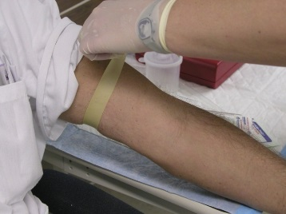
The nurse will be responsible for performing venipuncture on all participants at the community field laboratory. After obtaining consent, the Nurse will be given only two chances to collect blood from each participant.
- Always remember to practice Universal Precautions
- Assume that all human blood is potentially infectious for HIV, HBV, and other infectious agents.
- Use gloves and any additional personal protective equipment (PPE) if available (e.g., eye protection, lab coats)
- Always use sterile, single-use disposable supplies for sample collection.

- Preparing for venipuncture

- Obtain informed consent for blood collection
- Lay out a clean disposable absorbent pad on a table at the central field laboratory
- Lay out all blood collection supplies and necessary labels. Assemble needle or butterfly needle into Vacutainer holder being sure that it is firmly seated into threads.
- Loosely place Vacutainer tube into holder, but do not puncture top
- For each participant, wear a new pair of clean gloves and conduct all procedures on a new, clean disposable absorbent pad

- Venipuncture Procedure

- Check the ID bracelet against remaining lab labels
- Make sure the participant is sitting comfortably. For small children, have the mother or caretaker hold the child on her lap comfortably and instruct the mother on how to hold the child to minimize the child’s movement during the venous sample collection.
- Examine both arms to find the best vein.
- Locate the puncture site and apply the tourniquet
- Cleanse the area with an alcohol wipe by wiping in a circular motion making sure the area is thoroughly cleaned
- Repeat with a second wipe, if necessary
- Dry with gauze

- Fix the vein by pressing down on the vein about 1 inch below the proposed point of entry
- Remove the butterfly needle shield
- Approach the vein in the same direction the vein is running, holding the needle so that it is at an approximately 15º angle with the participant’s arm.
- Push the needle, with the bevel facing up, firmly and deliberately into the vein.
- Activate the vacuum collection tube by pushing the tube onto the needle and puncturing the tube top.
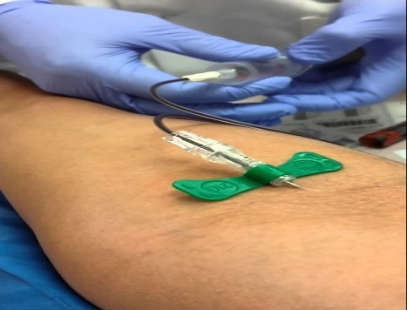
- If the needle is in the vein, blood will flow freely into the tube.
- If no blood enters the tube, probe for the vein once or twice until entry is indicated by blood flowing into the tube.
- After blood flow is established, loosen the tourniquet immediately and release entirely as the last tube fills.
- For all participants, fill one Blue Top Vacutainer with ~5 mL blood
- Fill one Purple Top Vacutainer:
- You will need a minimum of ~2 mL of blood for PSC and SAC
- You will need a minimum of ~3 mL blood for WRA and Men
- For the MRDR sub-study, fill a second Purple Top Vacutainer with ~3 mL blood

 | Blue Top-Vol (mL) | Purple Top-Vol (mL) | MRDR Purple Top-Vol (mL)
PSC | 5 | 2 | 3
SAC | 5 | 2 | 3
WRA | 5 | 3 | 3
Men | 5 | 3 | n/a

- Upon completion of blood collection, withdraw the needle. Applying heavy pressure as the needle is being withdrawn should be avoided.
- Have the mother/caregiver continue to hold the gauze in place for several minutes. This will help prevent hematomas.
- Invert the Purple Top Vacutatiner 10 times after blood collection so that the blood will mix with the EDTA in the tube to prevent clotting. Gently invert the Blue Top Vacutainer 5 times after blood collection to mix with clot activator
- Place an adhesive bandage on the participant’s arm
- Label all tubes with the correct and corresponding labels provided (i.e “Purple Top Vac” or “Blue Top Vac”)
- Place the correct corresponding “Specimen Ctrl” label on the “Biological Specimen Control Form” and complete the necessary information
- The needle should be discarded into a sharps container.
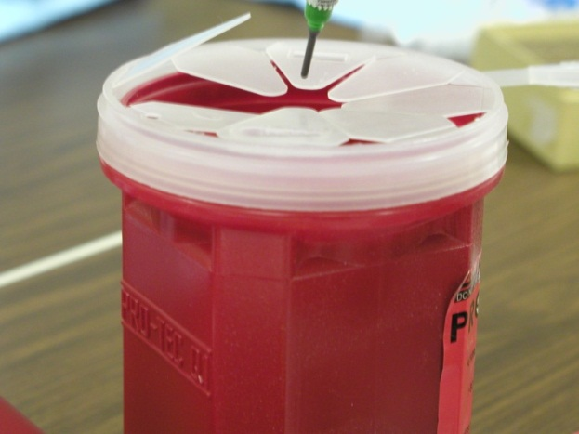
- Place labeled tubes into a rack inside a cold box with frozen gel packs and discard waste into a biohazard bag.
- Proceed to perform field testing from the Purple Top Vacutainer (see Protocol for field testing ) prior to transferring specimens to Laboratory Technician for processing
- Report to the team leader/supervisor any reaction experienced by the participant during the venipuncture procedure

Annex 7a: Freezer Temperature Monitoring Form
Freezer Temperature Monitoring Form (-20°/-70°C)
Region:

Survey Laboratory Coordinator:
Regional Laboratory Technician:
Freezer Information (i.e., type)
- To be used to monitor freezers located in district/regional laboratories
- Please monitor the temperature of the freezer daily and record the date, time, temperature, initials, and any observed issues with the operation of the freezer.
- Report any issues to the Survey Laboratory Coordinator.
- Freezers will only be used to store processed specimens: a) until they are transferred to Addis, for analysis, after data collection is complete; b) stored long-term as back-up specimens.
- Do not store processed specimens in refrigerators!

Date | Time | Temp., ˚C | Initials | Observations

Annex 7b: Refrigerator Temperature Monitoring Form
Refrigerator Temperature Monitoring Form (1°- 6°C)
Region/EA:

Survey Laboratory Coordinator:
District/Regional Laboratory Technician:
Refrigerator Information (i.e., type)
- To be used to monitor refrigerators located in the district labs.
- Please monitor the temperature of the refrigerator daily and record the date, time, temperature, initials, and any observed issues with the operation of the refrigerator.
- Report any issues to the Survey Laboratory Coordinator.
- Refrigerators will only be used to store the MRDR doses. When a refrigerator is not available, a cold box with frozen gel packs will be used.
- Do not store processed specimens in refrigerators!

Date | Time | Temp., ˚C | Initials | Observations

Annex 8: Procedure for Malaria testing using Rapid Malaria Antigen P. falciparum HRP2 Test Kit

Overview of the SD Bioline Malaria Antigen P. falciparum (HRP2) Detection Rapid Card Test
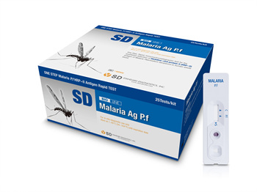
The nurse will be responsible for performing Malaria testing on all participants at the central field laboratory. The SD Bioline Malaria Antigen Detection Rapid Card Test contains a membrane strip which is pre-coated with a monoclonal antibody across the test strip for the detection of HRP-II antigen of P. falciparum.

Special Considerations for Kit- Storage and Use:
- The malaria kits should be stored at 4-40°C.
- Keep kits out of direct sunlight.
- Do not open a kit until you are ready to test for malaria.
- Do not use the kit beyond it expiration date.
- Do not use the kit if it has been damaged.
- Follow Universal Precautions when using the kit:
- Assume that all human blood is potentially infectious for HIV, Hepatitis B, and other infectious agents.
- Wear gloves and safety glasses
- Dispose of all materials in a biohazard bag.
- Always use sterile, single-use, disposable supplies for sample collection.
Procedure for Malaria Testing:
- Set the timer to 15 minutes.
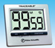
15:0000
- If the assay buffer has never been used, twist the cap of the buffer tightly to pierce the opening so that the buffer can flow out of the bottle.
- Remove the cap from the Purple Top Vacutainer
- Using a disposable transfer pipette, gently pipette a drop of whole blood onto a piece of parafilm
- Using the specimen pipette provided, immerse it into the drop of whole blood
- Collect 5 µL blood. Gently release the pressure on the bulb of the specimen pipette to draw blood into the pipette up to the pipette guide line.
- Add 5 µL blood into the “Sample Well” by squeezing the pipette bulb.
- Add 4 drops (90~120 µL) of assay buffer into the “Buffer Well.”
- Start the timer, and wait for 15 minutes
- Read the test result.
- DO NOT EXCEED 15 MINUTES BECAUSE THE RESULTS MAY BE INACCURATE.
Interpretation of the Malaria Test
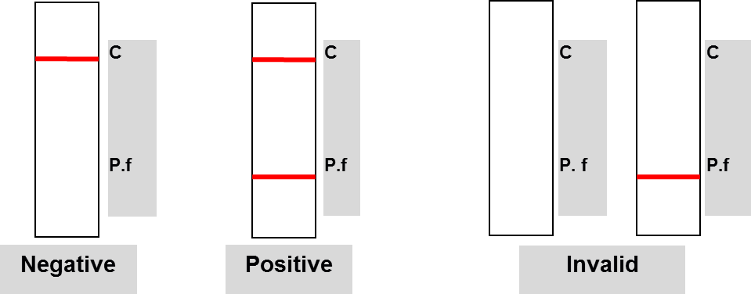

- Record participant’s results on the Questionnaire.
- For positive malaria results, complete a “Referral Slip” and refer the participant/caregiver to the local health center/clinic.

Annex 9: Malaria Status and Referral Slip
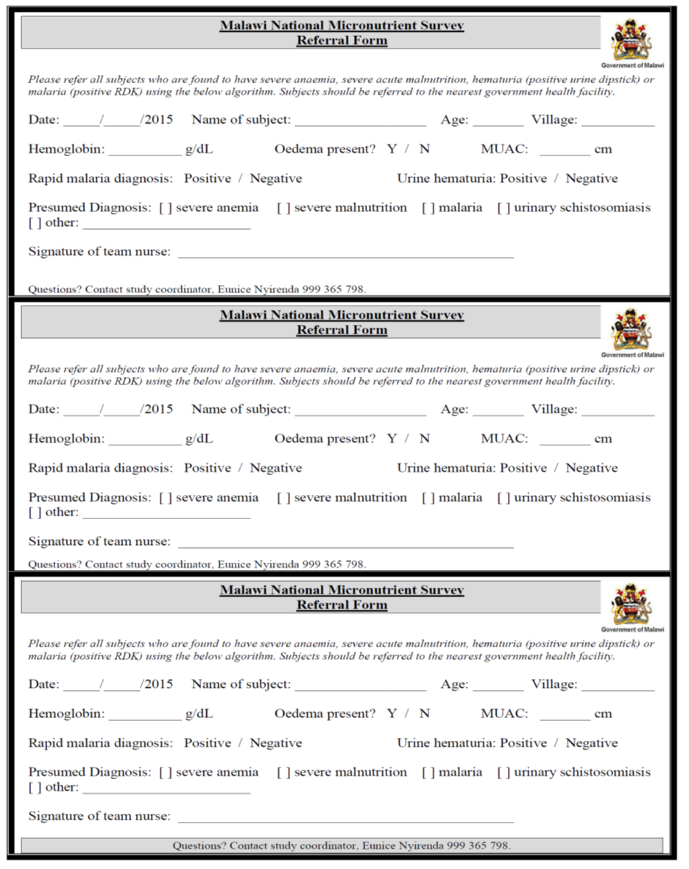
Annex 10: Directions for Urine Collection

Give a labelled urine cup to each child 6-9 years and woman 14-59 years and explain the following before the urine collection:

- Hands should be washed with soap and water.

- The collection cup should not be opened until just before urinating.

- The person should leave the cap turned up (demonstrate this) while urinating, then immediately recap the filled container tightly.

- It is most important that the inside of the container and the cap not be touched or come into contact with any parts of the body or clothing or external surfaces.

- Collect the capped specimen from the subject and make sure that the cap is secured tightly.

- Place each collection cup into cold box containing frozen gel packs.

- After sample collection, record information for each specimen collected on the “Biological Specimen Control Form” (Annex 3a).

Annex 11: Procedure for Measuring Hemoglobin Using the HemoCue 301-Photometer and Maintenance of HemoCue

The nurse will be responsible for measuring hemoglobin (Hb) on all participants at the central field laboratory. HemoCue Hb-31 is used to check the hemoglobin concentration in the blood. This is a robust instrument that can give accurate readings in a field setting. However, errors in Hb assessment occur if appropriate procedures and techniques are not followed. Use of inappropriate procedures/techniques may cause wide variations in Hb values leading to erroneous estimates of anaemia prevalence in the population.

- Measuring Hemoglobin using HemoCue 301:

- All materials needed prior to testing each subject should be assembled
- Turn ON the HemoCue Hb-301 photometer. As this instrument has self-test, it does not have a control cuvette and does not need any liquid controls.
- In about 30 seconds three lines show up the photometer screen (- - -).
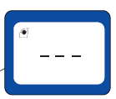

- Collect blood from the Purple Top Vacutainer :
  - Remove the cap from the Purple Top Vacutainer
  - Using a disposable transfer pipette, gently pipette a drop of whole blood onto a piece of parafilm. Use the tip of the cuvette to fill the cuvette.
  - Make sure the cuvette is filled properly and that there are no bubbles
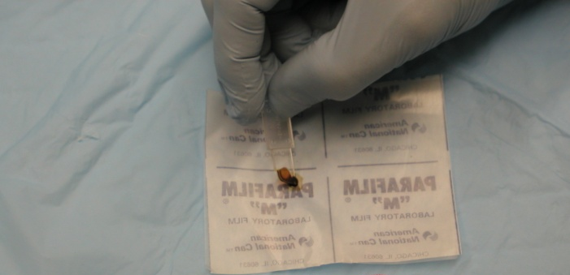

- Clean any excess blood from the cuvette using a Kimwipe or a tissue paper. Do not touch the open end of the cuvette with the wipe. Inspect the cuvette for air bubbles, and if any air bubbles are seen, discard the cuvette and use a fresh cuvette.

- Place the cuvette in HemoCue holder and gently close the holder into the photometer. The results will be displayed in approximately 10-20 seconds.

- Record the hemoglobin results on the “Hemoglobin Status and Referral Slip” and give to participant’s mother or caretaker. Explain the result to the mother/caretaker. Dispose of the cuvette in sharps container. Refer participant to the local clinic if participant is severely anemic.

- Properly discard all used materials according to the biological waste disposal laws of Malawi.

- HemoCue 301 Maintenance:

- At the beginning of each survey day, ensure that the instrument is clean (i.e., free of blood and dirt), operational (i.e., turn on the instrument to test for any errors) and contains batteries.
- If readings are in question, clean the cuvette holder with a dry KimWipe and dry completely before measuring the hemoglobin.
- If readings continue to be outside the correct range (<4 g/dL or >18 g/dL) or reads ERROR, do not use the instrument. It should be serviced or replaced.
- Perform daily QC by measuring and recording the results for each of the low, normal and high range control vials on the “HemoCue® Hemoglobin Quality Control Form”
  - This is to be done in the morning (before blood collection begins)
  - Be sure to store QCs in a refrigerator (1-6°C).

- HemoCue Trouble Shooting Guide:

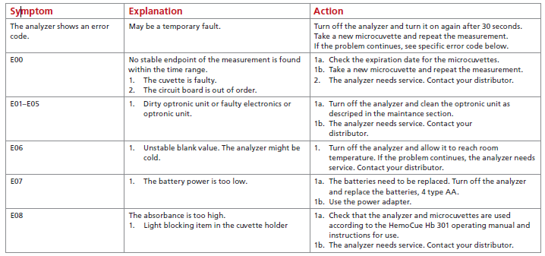

Common Problems to Avoid:

The key points to be strictly followed during the use of HemoCue 301:

1) Keep the instrument clean, especially the cuvette holder.
A swab dabbed with alcohol can be used to clean away any dirt or dried blood. This should be done at least once a day or when there is a visible build-up of dirt or blood. Be sure the cuvette holder is dry before re-inserting it in the machine.

2) Keep cuvettes clean, dry and away from heat.
Cuvettes in closed containers are good for 3 months after opening. Always keep the container lid closed when not in use to avoid unnecessary exposure of the cuvettes to air, especially in humid conditions. Heat and moisture will denature the chemicals in the cuvette which can lead to inaccurate Hb measurements.

3) Avoid use of poor techniques.
  - DO not touch cuvettes with wet fingers. Avoid removing a cuvette from its container when your fingers are wet with alcohol. Alcohol coming in contact with the cuvette can denature the needed chemical in the cuvette selected, as well as, other cuvettes still in the container.
  - Adequately fill the cuvette. The cuvette needs to be filled with a drop of blood in one continuous motion. Again this depends on the flow of blood and the size of the drop formed; if it is not adequate, the cuvette will not fill adequately. Do not “top off” the cuvette that is not completely filled. This results in erroneous Hb readings...usually too high. Any sign of air-bubbles means that the cuvette has not been filled adequately and should be discarded and a new cuvette used. The presence of bubbles will usually underestimate the Hb reading.
  - Do Not “slam” the cuvette holder into position for reading. This will avoid spraying blood droplets into the cuvette holder which can hamper the scanner.

- Summary of common problems and solutions related to capillary sampling and use of the HemoCue 301 photometer:

PROBLEM | SOLUTION
Not preparing all needed materials before testing a subject. | Place cuvette and vacutainer on work surface; turn on photometer; pull out the cuvette holder to “locked” position so that digital screen reads “READY”; put on latex gloves.
Selecting a cuvette from its jar with fingers wet with alcohol (the alcohol denatures the chemicals inside the cuvette; thus, the selected cuvette as well others inside the jar can be denatured). | Take cuvette out of its container before handling a wet alcohol swab.
Holding cuvette in inverted position (slit facing down) during filling (this can lead to air bubbles being trapped resulting in erroneous result). | Hold the cuvette with the slit facing up and the pointed tip touching the blood drop.
“Topping off” a partially filled cuvette with repeated blood collection (the reagents in the cuvette are denatured upon contact with the initial amount of blood; red cells of blood introduced later will not be adequately analyzed). | Allow a large blood drop to form on the heel/finger so that it will completely fill the cuvette in one motion. Once filled, hold the cuvette in place for about 2-3 seconds longer to ensure complete filling.
Not cleaning off blood on outside of cuvette before testing (can result in erroneously high Hb reading). | Wipe off excess blood from sides of cuvette using a “butter knife” motion to ensure that blood from inside the cuvette is not removed.
“Slamming” the cuvette holder into place (can lead to blood drops spattering inside the reading chamber). | Push the cuvette holder gently into position. Once or twice a day clean the cuvette holder with alcohol swab and completely dry before testing. Periodically clean the reading chamber with dry gauze.

Annex 12: Hemoglobin Status and Referral Slip

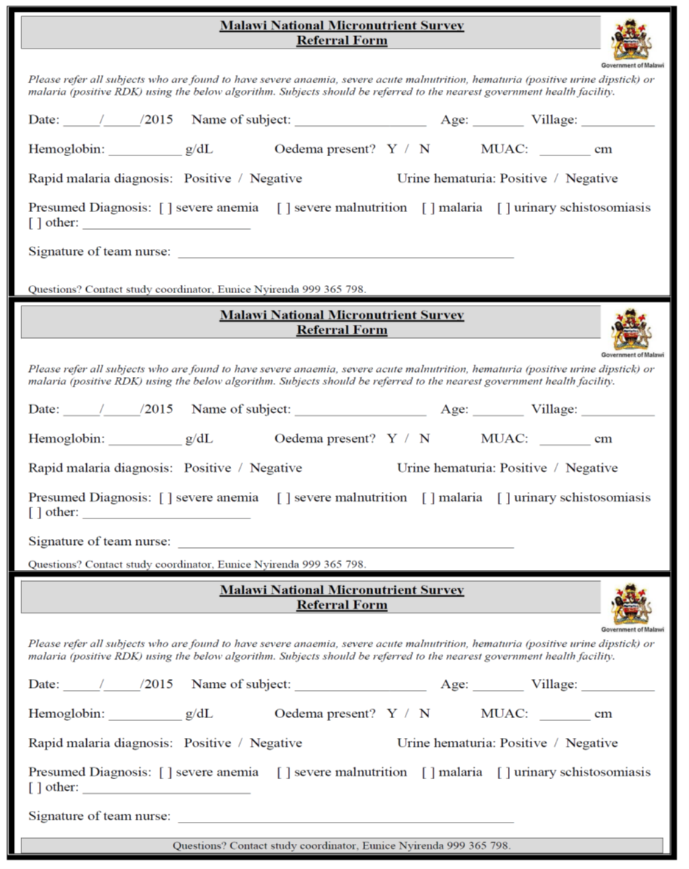

Annex 13: Procedure for preparing, drying and storing Dried Blood Spot samples

PURPOSE:

Dried blood spots (DBS) refer to whole blood collected on special filter paper (S&S 903) and dried. Blood collected in EDTA Purple top vacutainers will be used to prepare dried blood spots for haemoglobinopathies testing. All the DBS samples prepared in the field lab will be stored at CHSU, then transported to the US for storage and future testing.
The nurse is responsible for:
- Properly collecting DBS
- Labelling and storing specimens appropriately until transported for storage

Collection of blood in the form of a dried blood spot (DBS) allows storage and shipping of the blood for future laboratory testing, including analysis of hemoglobin and genomic DNA. GE Healthcare Life Sciences sells Whatman® brand patented cards that are designed to simplify this process. DBS cards hold a fixed amount of blood, and after drying at room temperature, can be stored for future testing. DNA is stable using room temperature collection, shipment, and storage, while hemoglobin requires frozen cards to preserve the proteins. The cards accommodate fresh blood such as blood collected in the EDTA Purple Top Microtainer.
SAFETY AND PRECAUTIONS:
- Store DBS cards in a dry place and refrigerate for best quality
- Store other reagents at room temperatures for short-term and long-term use
- Always wear Personal protective equipment (PPE) gloves throughout the entire collection procedure; to protection to yourself, others, and avoid contamination of DBS cards
- Follow universal precaution when handling biological specimens
- Special care should be taken to prevent cross-contamination of samples
- Always label cards to ensure the corresponding barcode label is present
- Put all finished DBS cards into freezer for long-term storage

PROCEDURE:
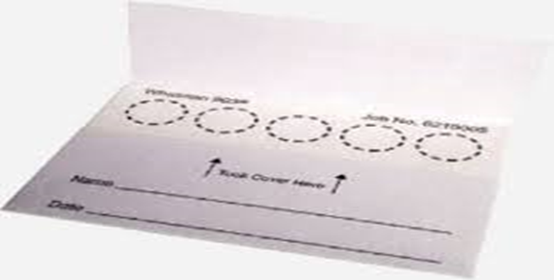
Equipment:
- Whatman 903 filter collection card (2 sample areas, each holding 125L of blood)
- Sealable Ziplock plastic bag for DBS card storage
- Desiccant packet for card storage
- Gloves (PPE)
- Drying rack
- Labeled Purple Top (EDTA) Vacutainer (containing blood)
DBS preparation process:
- Collect venous blood by venipuncture using standard practice (see Annex 6)
- Mix collection tube well by inverting several times, to anticoagulate the blood
- Write the date as dd/mm/yyyy on filter card
- Stick the corresponding child’s barcode label in the space labelled “Name”.
- Ensure that the barcode matches the one on the Vacutainer.
- Place the labelled filter paper horizontally on a drying rack
- Remove vacutainer top
- Pipette 125µL blood directly on DBS card circle: position the pipette vertically approximately 1cm above the filter paper card and dispense the blood in the middle of the first printed circle.
- Spot blood on two circles per participant
- Do not touch or smear the sample on the filter paper
- Allow to dry (see below):

Drying the DBS card:
- Place the completed DBS card into a drying rack to dry
- Place one card per slot to prevent cards from touching each other
- Allow each card to dry for 2-3 hours. Do not artificially dry with heat or sunlight
- Blood spots should be a dark brown color once dried
- Dried cards should be placed into a large Ziplock plastic bag with desiccant
STORAGE
Store DBS cards frozen at -20C or -70C to maximize the potential DNA yield.
HANDLING FILTER PAPER
Filter paper must be handled with great care so as not to contaminate or otherwise ruin the DBS.

- Avoid
  - Touching bare-handed
  - Touching the circles even when wearing gloves
- Avoid exposing to
  - Powder and dust
  - Water/moisture
  - Alcohol
  - Direct sunlight
  - Other contaminants
- Label clearly
- Do not place the filter paper on the bench surface when labelling or collecting DBS
- Be sure to place the filter paper on a drying rack before adding blood specimen
- Ensure paper remains in a horizontal position until sample is completely dry (overnight)

PACKAGING AND TRANSPORTATION OF DBS

Packaging of DBS is done on the subsequent day (i.e., after at least 16 hours of drying the DBS).

Annex 14: Procedure for Hemoglobin Measurement using anemocheck

Materials needed:
- Parafilm
- 5µL capillary tube
- EDTA Purple top Vacutainer
- Chemical tube with prefilled solution
- Tablet computer
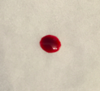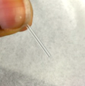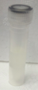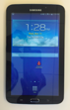

Procedure:
- Remove one chemical tube
- Using a disposable pipette, place one drop of blood from the purple top Vacutainer on the parafilm
- Place the provided 5µL capillary tube in the drop of blood
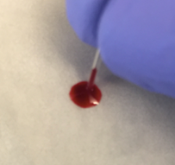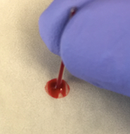

- Allow tube to fill completely
- Check to see if capillary tube is completely filled and that there are no bubbles

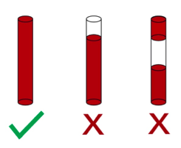
- If the capillary tube is partially filled or has bubbles, repeat step 3-4 in order to fill a new separate capillary tube with blood
- Unscrew the top of the chemical tube
- Place the capillary tube into the chemical tube (pre-filled with a solution)
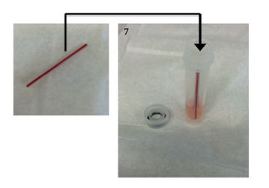

- Screw the cap on
- Shake vigorously for 5 seconds
- Make sure all the blood from the capillary tube is mixed with the solution in the tube
- Wait 2 minutes for the solution to change color

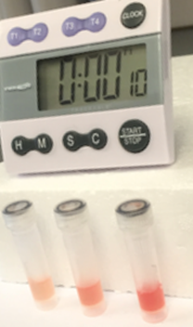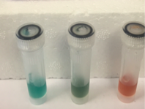

- Record the color of the liquid. Using the color scale below, interpret the Hgb value and record it in the boxes labeled “Visual”. If the color falls between two colors it is okay to assign a value in between
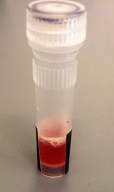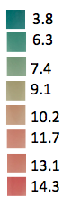

- Open the Sanguina AnemoCheck App on the tablet and select "Read Test Results"
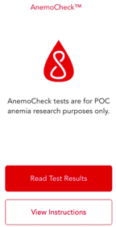
- Hold the chemical tube in front of the camera so that the colorful solution fills the rectangle
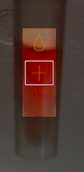
- Select "Take Photo"
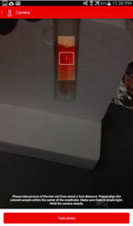
- Record the Hb value, which should appear at the top of the screen, on the questionnaire. Then select "Re-Take Image" to test another solution.
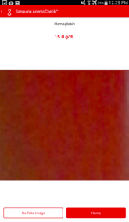
- Record the color that the test appears to be on the questionnaire.
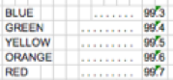

Annex 15: Flowchart-Responsibilities of the Nurses (highlighted in red)

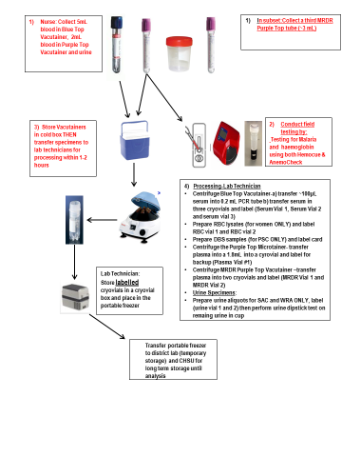

Annex 16: Flowchart-Responsibilities of the Laboratory Technicians (in red)
